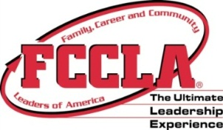
NAME:______________________ Period____
FCCLA-
Family, Career and Community Leaders of America®
STEP ONE QUESTIONS
Answer | STEP ONE Question | Answer | STEP ONE Question
 | - What does FCCLA stand for? |  | - Describe Student Body.  List the three Student Body Units.
 | - What is the name of the National Outreach Program? |  | - Describe Career Connection.
 | - How many National Executive Council Members (National Officers) are there? |  | - What does STAR (for STAR Events) stand for?
 | - Where is the next National Leadership Conference? |  | - What does STOP (for STOP the Violence) stand for?
 | - List the two goals of the Families First program. |  | - Name the three R’s in membership?
 | - What does FACTS stand for? |  | - How many members and chapters have joined nationally?
 | - Define Financial Fitness. |  | - What is the official magazine of FCCLA?
 | - Describe Power of One. |  | - When is National FCCLA Week?

